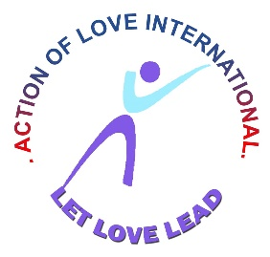

**ACTION OF LOVE INTERNATIONAL**

**DISABILITY PROJECT**

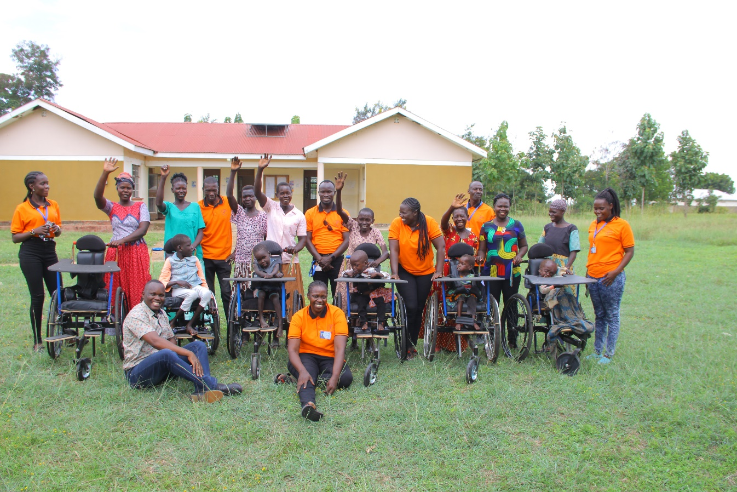

**PHASE 1 SUMMARY REPORT**

**AUGUST 2022**

**EXECUTIVE SUMMARY**

Action of Love International is pleased to present the Phase 1 summary report for the Disability project, implemented in Kapujan Sub County in Katakwi district, Uganda for the year 2022 by AOLI with funding and technical support from PBF. AOLI sought to develop evidence and programming guidance for matching contextually appropriate economic interventions with specifically targeted households to improve the livelihoods of the households as well as the disabled children in these households. As a sub-project on treatment, mobility and business capital, this provided a practical context for learning by AOLI and its stakeholders. AOLI sought to develop a strategy of helping the needy disabled children in the said Sub County and district of operation to aid their mobility as well as improve on their general health and livelihood. This report therefore, describes the project and summarizes achievements, challenges, and learning.

The goal of AOLI is **promoting empowerment of disabled children in achieving poverty eradication, isolation and violence** with the development objective that targeted the health of the disabled children and communities through provision of health services. The Disability project Phase 1 underwent implementation in Katakwi District particularly Kapujan Sub County which was the target project scope. The first phase of this project aimed to extend support to 7 beneficiaries, including provision of social support to the 7 affected families that harbor these 7 disabled children.

AOLI achieved its full enrolment target for the disability project Phase 1, 7 disabled children were identified, assessed for mobility and other illnesses, and enrolled for support for wheelchairs, heifers and social capital. AOLI reached 100% of its support target: 7 children were medically assessed and treated, they were provided with wheel chairs, heifers and their families given business capital to aid in the day-to-day household expenses as well as act as emergency fund for these households. So many of the children needed the same kind of support, however, AOLI was not able to extend it to all 137 children identified for a variety of reasons including the constrained resource envelop, and Phase 1 project target population size. Of the 7 disabled children approved for support from Kapujan Sub County, all fully benefitted from the project, subsequent to full consent by the parents/caretaker and the index child. Overall, AOLI worked with 7 disabled children (7 families); 100% of enrolment target reached.

**Summary of Conclusions**

AOLI has demonstrated love to the disabled children of Kapujan Sub County, with a lot of keen interest in supporting these children attain a fair life in terms of mobility, treatment, and social capital support. It also looked at building preventative resilience effort at the household level with family strengthening interventions at community level. Support for families where the disabled come from is much more difficult, the household needs are likely to be greater and perceptions of stigma are real. It is too early to tell whether participating households are in fact more resilient to shocks as they may arise in the future but never the less we try to empower them in preparation for the unknown. The Disability project benefitted from partnership with friends who are already deeply committed to the issues affecting the disabled children, though other partnerships may have enhanced outcomes.

The Disability project in this Phase 1 had important achievements as well as challenges that limited achievement on some desired outcomes. These challenges are themselves important contributions to the learning agenda around disabled child(ren) isolation and violence which should be taken into consideration in future program design.

**PROJECT BACKGROUND**

The Disability project is led by AOLI, a non-governmental organization that is working with communities to address issues arising from areas such as education, health, food security, agriculture, and livelihood in both the development and emergency contexts. AOLI works towards sustainable development and strives to respond to the real needs of the disabled persons in Teso Sub Region. In May 2022, AOLI, in partnership with PBF, received funds to empower disabled and vulnerable children to overcome poverty, isolation and violence through provision of mobility support, assessment and treatment, livelihood improvement, health improvement, strengthen food security and provide child rights for its beneficiaries.

Action of Love International employs the Vision, Mission and the Objectives below to run its activities;

**Vision**

Healthy and wealthy communities experiencing God’s love.

**Mission**

“To empower disabled, orphaned, and vulnerable children to overcome poverty, isolation, and violence”. Our mandate is committed to serve as an effective hub for delivering development programs for empowering disabled persons, poverty eradication on a sustainable basis in Uganda and beyond.

**Objectives**

1. To provide social support to the disabled persons.
2. Provide education services through sponsorship for the orphaned and vulnerable children.
3. To provide water and sanitation to the affected communities.
4. To improve the health of the children and communities through provision of health services.
5. Improve food security amongst the benefiting communities.
6. Provide child rights and equity.
7. To provide Vocational skills training.

**THEORY OF CHANGE**

***The Theory of Change considered that if families were provided a combination of economic and family strengthening interventions, the drivers of disabled-child support would be enhanced; families would become more resilient to shocks and would be able to foster a healthy environment for their disabled children.***

**TECHNICAL APPROACH**

AOLI’s household - centered approach to unnecessary child-family separation sought to explore a Theory of Change around resilience capacities of families. The Theory of Change was based on AOLI’s years of existence and the technical support from its staff to establish hypothesized pathways to address drivers of disabled-child support and increase resilience factors and capacities to enable families to meet their own needs.

**DELIVERY MODEL**

AOLI led and coordinated Disability project and provided technical leadership in the areas of economic strengthening, family strengthening and monitoring and evaluation. AOLI worked with the district stakeholders particularly the Sub County officials to help reach out to the families of the disabled children and also helped so much in monitoring of these project at grassroot. The project further engaged a cross section of partners, mainly local government officials, lower local council representatives and other community-based structures to identify beneficiaries, support implementation of activities and ensure sustainability of interventions.

Guided by a project logic organized around three intermediate results/objectives.

**Table 1 below summarizes the intermediate results and related activities.**

*Table 1 AOLI Interventions aligned to the Intermediate Results*

|  |  |  |
| --- | --- | --- |
| **IR 1: Assessment and Treatment** | **IR 2: Mobility Aid** | **IR 3: Social/Business Capital** |
| * Health Facility sourcing * Medical assessment * Treatment * Reviews * Follow up visit * M&E | * Mobility measurement taking * Special wheelchairs * Prosthetic legs & shoes * M&E | * Parenting skills training * Financial management training * Provision of heifers * Business capital * Psychosocial support * Family and individual counselling * Home visits * M&E |

**TIMELINE**

Following a refinement period in which AOLI selected beneficiaries, reviewed technical design issues, and prepared working tools in March 2022), activities to identify disabled children had already begun. Baseline data collection began in January 2020 and beneficiaries identified by February 2022; the exercise was straightforward and precise for disabled children but delayed for full implementation (May 2022 – August 2022).

Most economic strengthening and family strengthening activities of the affected families took place between May and August 2022. Phase 1 Project Evaluation took place in the second week of August 2022, as Phase 1 project was winding down for August 29th, 2022 close date. See Appendix 1 for AOLI Disability Project Timeline.

**WORKFORCE**

AOLI had had part-time staff including a Project coordinator, Accountant, Project officer, Accounts Assistant, and Field officers. In total, 4 Project officers delivered the Disability project activities in the field; guided by the Project Officer. The average caseload assigned to a single Field officer was 2 households. The Field officers understood the beneficiaries’ needs and challenges as they always related.

***Key Reflection****: AOLI learned that follow-up and support to families in both categories required adequate financial resource and training to be able to attend to the sensitive and often complex issues that were emerging from beneficiaries at family and personal level. AOLI also noted that some families often required frequent visits to be able to keep abreast of specific challenges, in particular among affected families. AOLI would recommend much emphasis on nutrition, provision of basic needs and beddings to its beneficiaries in the similar projects in future.*

**PROFILE OF PROJECT PARTICIPANTS**

AOLI’s Disability project worked with 7 families, inclusive of 38 HH members at baseline. Despite the number of HHs in the course of project implementation, we noted that the household membership increased to 41 members assessed at Phase 1 end line, likely due to births and new members joining or returning to the households as a result of better capacity to meet basic needs and provide stability.

*Table 2 Basic Features of AOLI Households at Enrolment*

|  |  |
| --- | --- |
|  | **Baseline** |
| **Household Membership**  Normal  Disabled | 41 HHs,  59 HHs, |
| **Children as % of HH members**  Normal  Disabled | 40%  60% |
| **HH head, by Gender**  Male  Female | 44%  56% |
| **Average HH Monthly Income** | UGX 58,980 (US $16) |
| **HH Source of Income** | * 30% of families’ main source of income was petty trading * 29% was casual labor * 20% was informal jobs * 6% of HHs had no source of income * 5% depended on remittances while the remaining earned through formal job employment, peasant farming, commercial farming and formal businesses |

**Child Vulnerabilities**

With the help of our Field officers, Disability project collected socio-demographic information on children living in affected families to understand their vulnerabilities. The following demographic data was collected: Age, sex, parenthood status of the children in the family, school attendance, school enrolment status, disability, chronic illness, immunization, birth registration, HIV status among the main areas. The information was gathered for all the disabled children targeted by the project.

The summary shared below is a representation of the situation of all the disabled children living in AOLI supported families (including the index children), at baseline:

* All the children were disabled
* All the children who had reached school going age were not enrolled in school
* 34% were orphans either without one or both parents, and this was the main vulnerability factor.
* 26% had a chronic illness

***Key Reflection:*** *AOLI team became aware of the above challenges and found ways to adapt the delivery model to better respond to the situation and context of participating households and mitigate some of the challenges. In future programs, attention should be paid to providing interventions as quickly as possible after identification of a household and to catching any delays or uneven trends in participation as early as possible for most effective course correction.*

**PERFORMANCE BY INTERMEDIATE RESULT (IR) AREA**

This section of the report describes, by intermediate result area, how the Disability project Phase 1 was implemented and its achievements.

**INTERMEDIATE RESULT 1: Medical assessment and Treatment of the disabled children so as to ascertain the medical conditions of these children and how to better handle these conditions.**

To deliver interventions under this intermediate result, three main strategies were used;

* Provide care and facilitate decision–making, tracing preparation and needs identification for treatment of the beneficiaries
* Develop and follow-up on use of the health facility and the services offered to beneficiaries.
* Ensure admissions to the health facility and referrals for critical services that are not offered by the health facility

A few case management activities are highlighted below due to their pivotal role in supporting and promoting achievement of the project objectives.

**Health Facility Sourcing**

During this, the health facility to which the beneficiaries were to be assessed and treated from was identified amidst consultations and visits to the some of the sampled health facilities selected. The sample was based on the services they offered, experience in the medical field as well expertise.

Bethesda Hospital Soroti (BHSL) was given an opportunity to assess and treat the beneficiaries. Bethesda is a Christian based hospital founded out of a desire to serve and provide quality medical care to the people of Teso sub region of Uganda. It has been in existence for 10 years and has served a reputation in the land.

BHSL offers a variety of services which are not limited to; Outpatient, inpatient, Dental, Ambulance, Neonatal ICU, Mortuary, Laboratory, Radiology, Physiotherapy, Pharmacy, Maternity, Wellness, Antenatal Care and Family Planning.

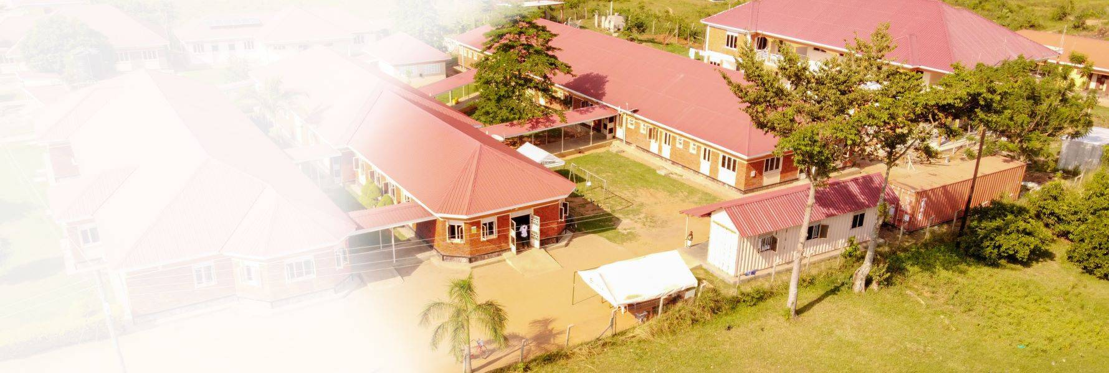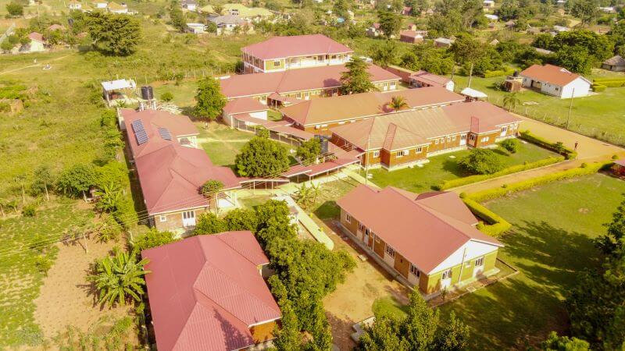

*Bethesda Hospital Soroti (BHSL) is a Christian based hospital located in Oderai, founded about 10 years ago.*

**Medical Assessment and Treatment**

The beneficiaries had difficulties in mobility and this was an action drawn towards supporting them acquire mobility devices. However, the beneficiaries did not just need assistance in mobility but also bettering their lives and make them compete fairly in a social environment. It therefore called for medical assessment and treatment of these beneficiaries to ensure that the support given is in accordance with their needs. A summary of the assessment and treatment given is as tabled below;

*Table 3: Summary of Assessment and Treatment per beneficiary*

|  |  |  |  |
| --- | --- | --- | --- |
| **No.** | **Name, Sex and Age** | **Disability Condition** | **Diagnosis Treated** |
| **1.** | Amulen Angela, Female (5 yrs) | * Cerebral palsy (CP) * Multiple sclerosis (MS) | * Malaria * Anemia |
| **2.** | Opio Emmanuel, Male (5 yrs) | * Mobility Impairment (MI) * Autism * Pervasive Development Disorder | * Pneumonia * Bacterial infection * Pneumonic Condition (x-ray) |
| **3.** | Achola Brenda, Female (5 yrs) | * Mobility impairment, Autism * Pervasive Development Disorder | * Malaria * Urinary Tract Infection (UTI) |
| **4.** | Apale Agnes, Female (5 yrs) | * Congenital Hydrocephalus (CH) * Autism * Pervasive Development Disorder | * Malaria * Pneumonia |
| **5.** | Elobu Samuel, Male (14 yrs) | * Mobility Impairment * Pervasive Development Disorder | * Malaria * Bacterial Infection |
| **6.** | Opolot Vincent, Male (20 yrs) | * Autism * Pervasive Development Disorder | * Pneumonia * Bacterial Infection |
| **7.** | Okori James, Male (7 yrs) | * Cerebral Palsy * Multiple sclerosis | * Severe Malaria * Anemia * Bacterial Infection |

**Reviews and Follow up Visits**

This was done to ensure that the beneficiaries get better treatment and also ensure the viability if the exercise at Bethesda. The reviews were during admission and the visits were after discharge. The treatment helped the beneficiaries come out of the medically diagnosed conditions.

***Key Reflection:*** *The field officers saw disparities during the assessment and treatment of the beneficiaries and some conditions couldn’t be handled in the facility as they needed special attention. In the next future, a resource envelop needs to be secured for conditions such as hydrocephalus and malnutrition.*

**INTERMEDIATE RESULT 2: Mobility Aid**

This intermediate result in the project is provision of mobility aid for the beneficiaries. Initially, we looked at specialized wheelchairs, prosthetic legs, arms and shoes. However, during the test for the above, the beneficiaries needed only wheelchairs; During this, the intended beneficiaries were medically assessed from Mbale Regional Referral Hospital Orthopedic department where the wheelchairs are manufactured from.

The wheelchairs were given to the beneficiaries from Kapujan Sub County headquarters in the presence of the Sub County heads (The Sub County Chief, The Community Development Officer, The Chairperson LC III and the Parish Chief).

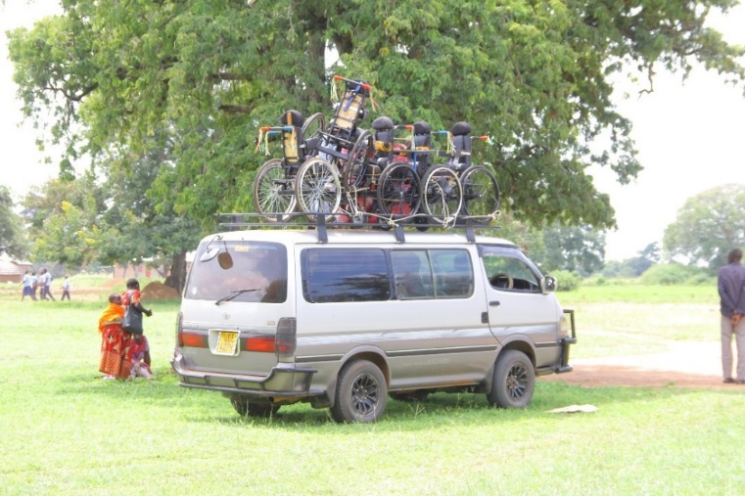

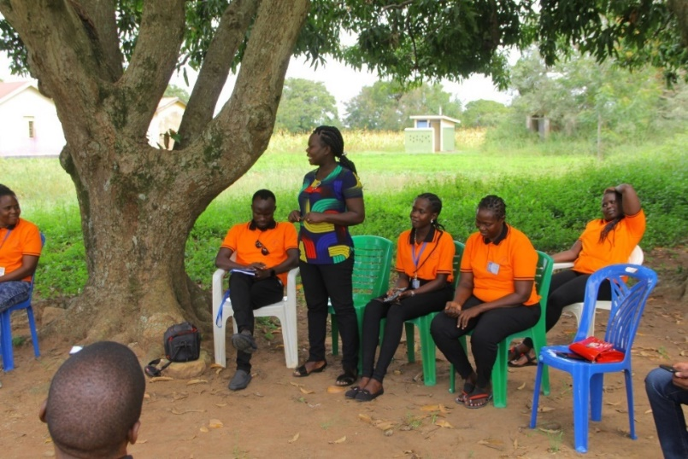*Wheelchairs arriving at Kapujan Sub County where the distribution took place.*

*AOLI staff making remarks before the distribution of the wheelchairs.*

*The SC officials making remarks, wheelchairs paraded & a field officer posing with a wheelchair*

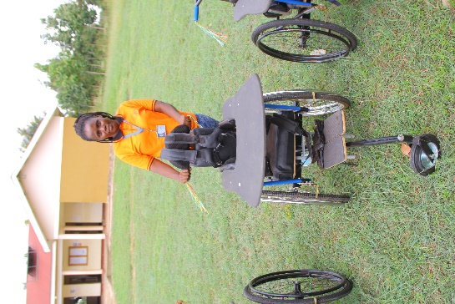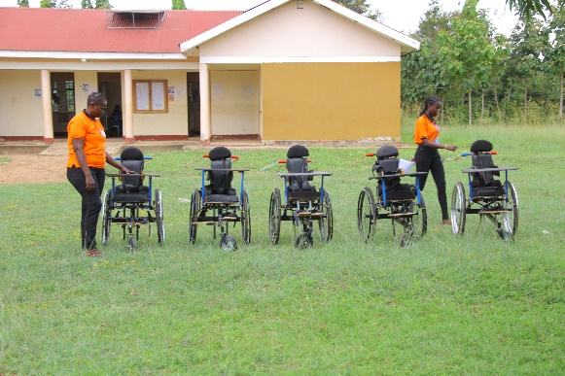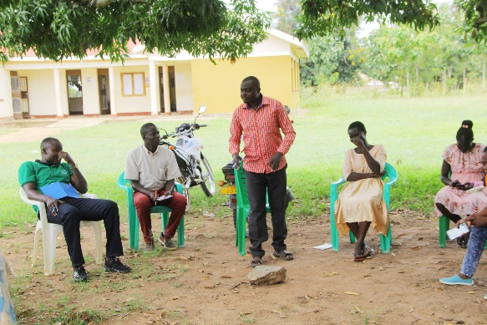

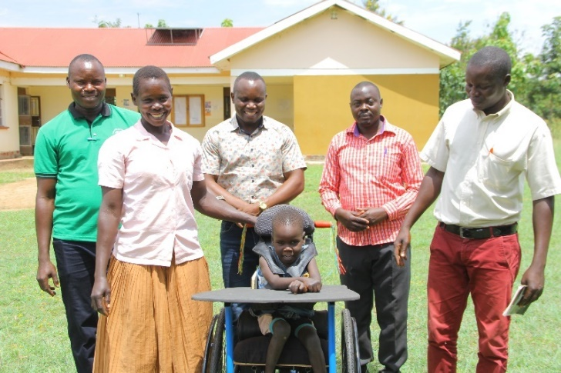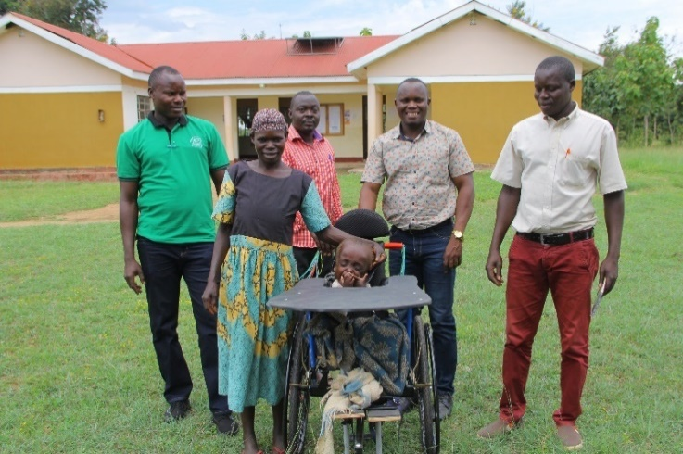

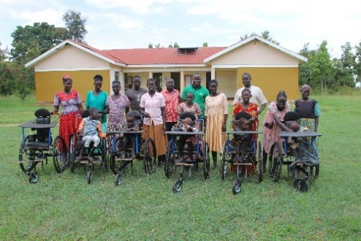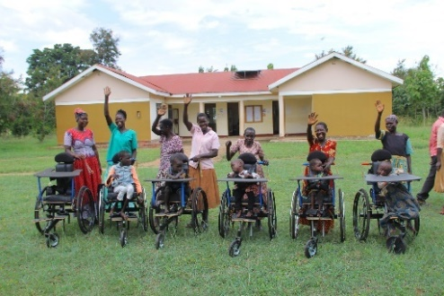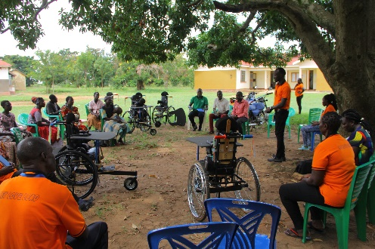*The beneficiaries receiving their wheelchairs from the Sub County officials and the ED.*

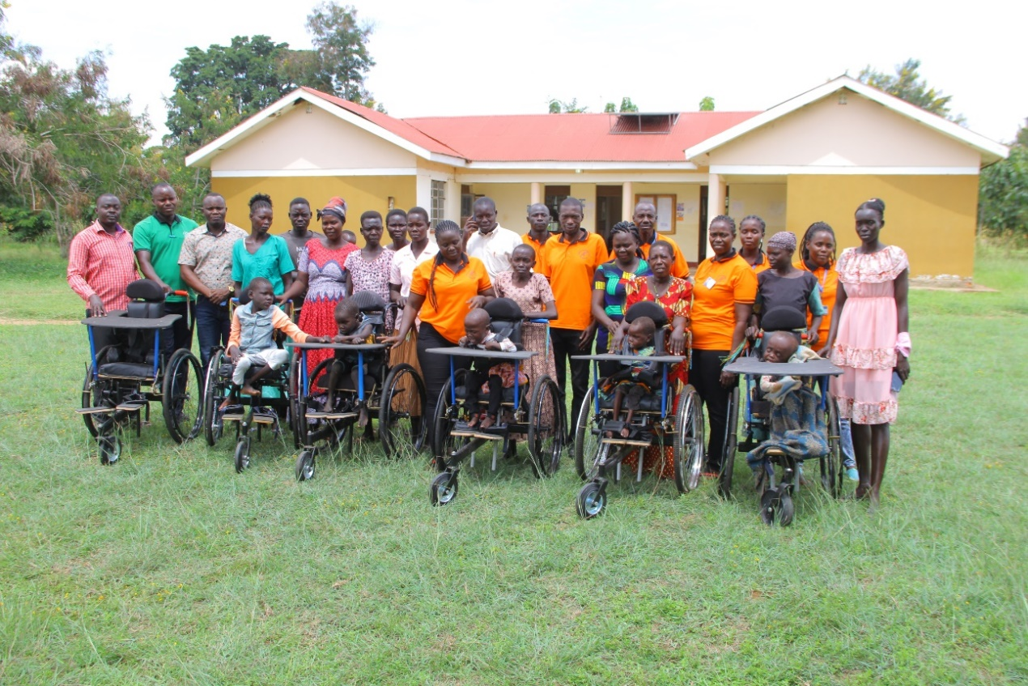

*AOLI staff pose for a group photo with beneficiaries and SC officials at Kapujan Sub County Headquarters.*

**INTERMEDIATE RESULT 3: Social/Business Capital**

Social capital is simply a positive product of human interaction. The positive outcome may be tangible or intangible and may include useful information, innovative ideas, and future opportunities. It can be used to describe the contribution to an organization's success that can be attributed to personal relationships and networks, both within and outside an organization.

Under this intermediate result, we looked at the following;

**Trainings**

The trainings targeted the parents/caretakers of the beneficiaries. In this way, the parents/caretakers of these beneficiaries are equipped with knowledge on parenting skills, financial management and other ways of creating a free environment for these disabled children.

The financial management equipped them with knowledge on handling finances as well as prepare them for the business capital that was given to them. It turned out to be a dialogue on which ways they can make more money from the money they received and how best to sustain their business and which business works best.

**Psychosocial Support, Family and Individual counselling**

Most of these target families are depressed due to the presence of these disabled children amidst the pandemic that had struck and the rising prices of commodities. These people are faced with challenges of running their own families as most of them depended on petty trading, casual labor and informal jobs. This created room for isolation of the disabled children and sometimes neglect and needed psychosocial support to help improve on their thinkability. Counsellors were hired that facilitated the whole psychosocial support as well as family/individual counselling and the beneficiaries’ caretakers left happy and motivated.

**Provision of Heifers**

The beneficiaries were provided with heifers to aid on the household source of income in the nearby future. The heifers were supplied by a supplier sourced by AOLI. The heifers were bought from a local market in Bukedea district, assessed, treated and kept a little while in preparation for distribution. The beneficiaries were excited to receive the heifers. The distribution was done by AOLI team together with Kapujan Sub County officials; the Sub County Chief, the Chairperson local council (LC) III, the Community Development Officer, the Parish chief and the Sub County Veterinary officer.

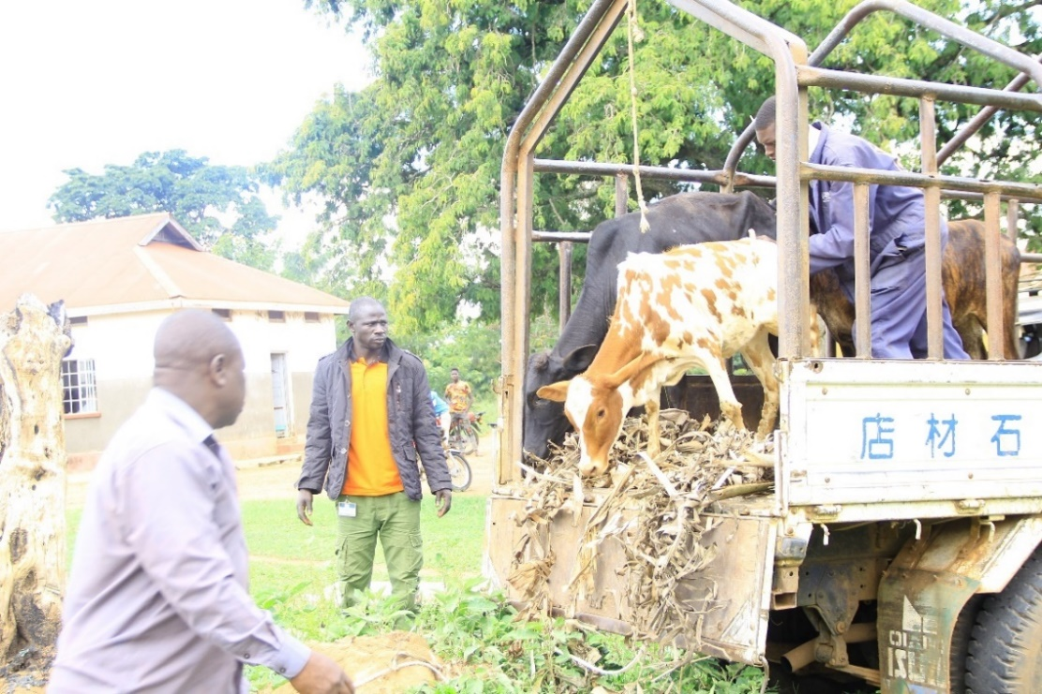

*Heifers arriving at the Sub County headquarters for distribution*

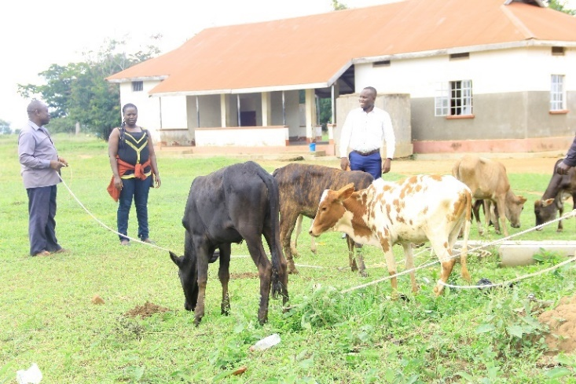 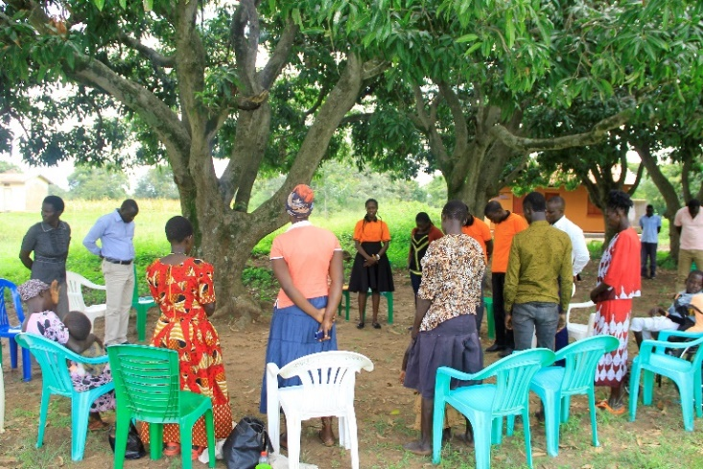

*The heifers, word of prayer to open the meeting, caretakers picking papers randomly for the tags and ED giving his submissions*

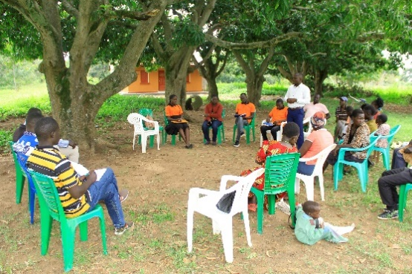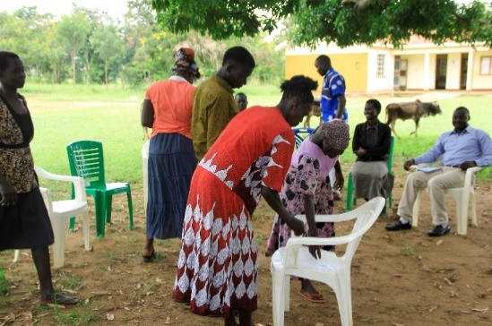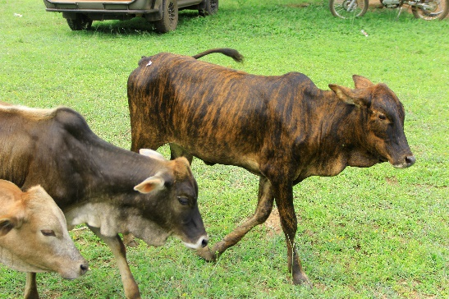

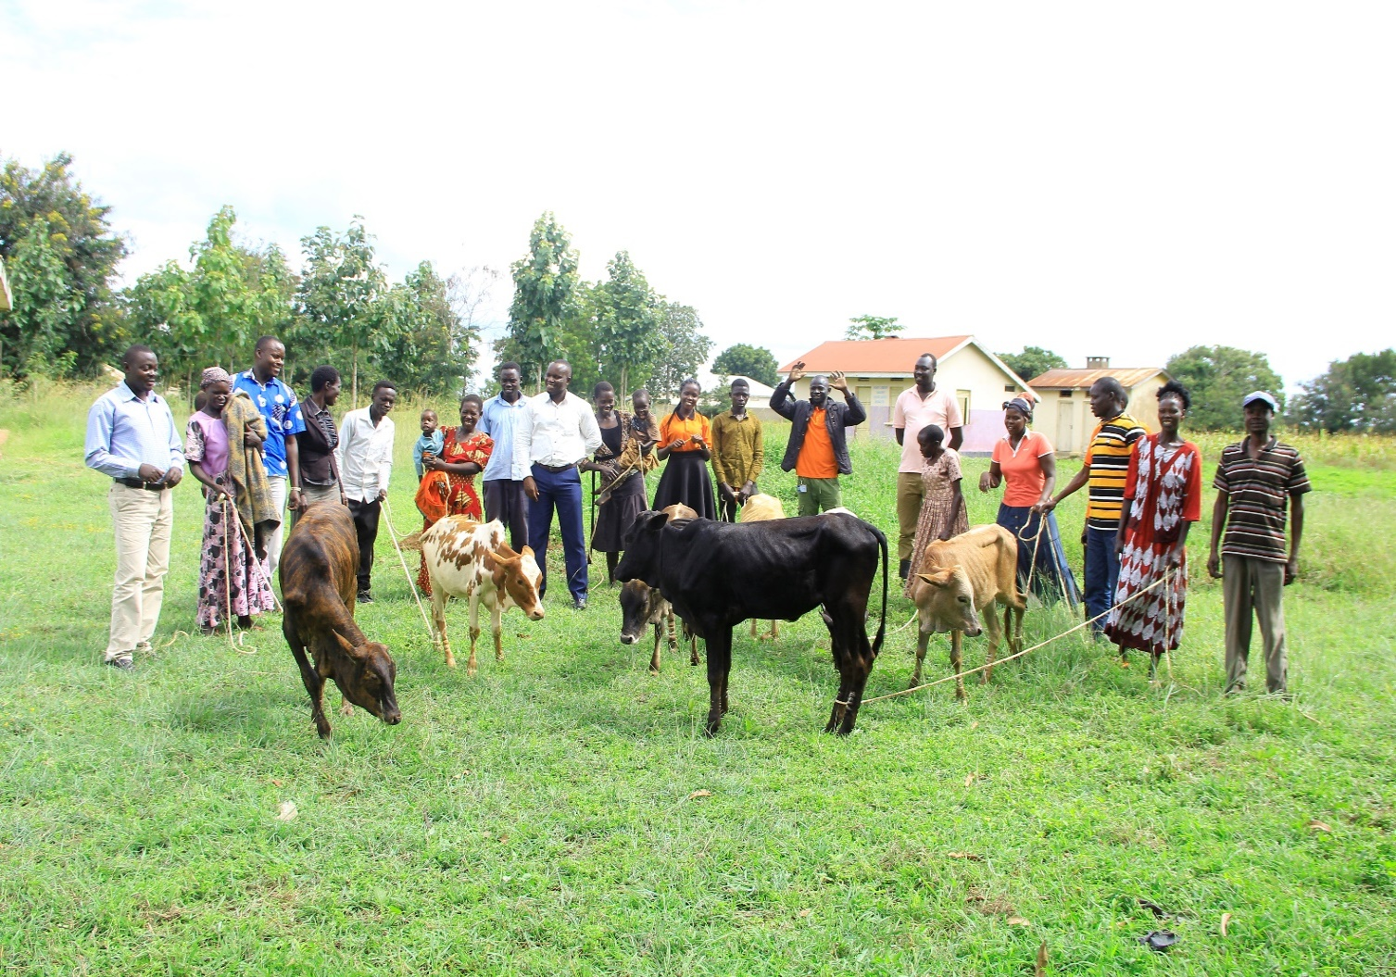Before the heifers were given out, a random/chance were given to the caretakers of the beneficiaries. Papers with tag numbers were rolled and displayed for them to pick at random. The number that the papers show after opening became the animal with that same tag number. It was an exciting and fun exercise that everybody participated with ease.

*AOLI staff together with the Sub County officials distributing the heifers to the beneficiaries*

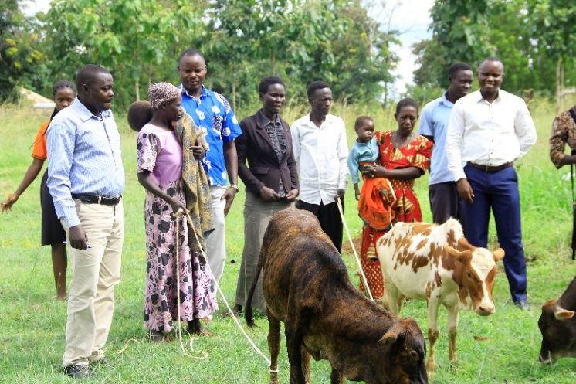 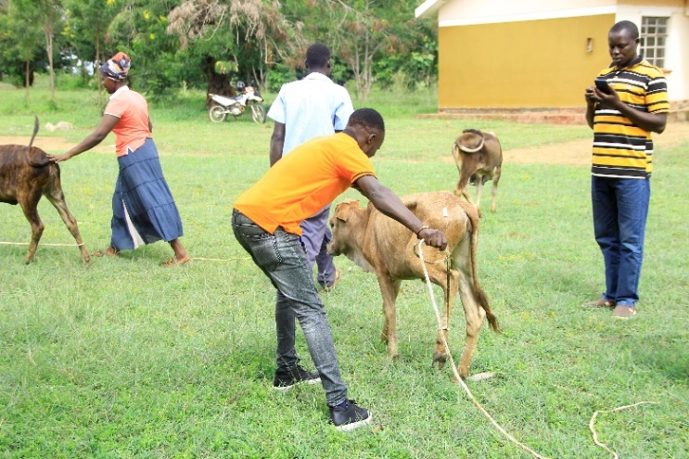

**Business Capital**

After a thorough consultation from the beneficiaries about business capital, a number of them suggested that they be provided with at least a modest business capital to facilitate their petty trading within their villages. On further inquiry by our field officers, almost all of them suggested that at least a minimum of Uganda Shillings 3,000,000 be provided for them to run their businesses. Of the businesses cited, local trading on items like tomatoes, onions, salt, sugar, maize flour and other items.

AOLI under intermediate result 3, has business capital on it and made sure that before the capital was handed over to the beneficiaries’ caretakers. They held a dialogue on proper management of this resource (business capital) to benefit the disabled children and their families at large. Guiding conditions were established, a form printed and endorsed by all the caretakers/parents of the beneficiaries. A penalty for misuse of the money was developed and made sure all the parents/caretakers understood.

**CONCLUSION**

The Disability project has demonstrated that preventative resilience-building efforts at the household level is a good approach, with family strengthening and economic strengthening interventions both of great relevance. While the results lack a counter-factual for full attribution, the data and targeting approach suggest that disabled-child neglect could very well have been prevented. Community-level engagement after support is easier, and families tended to be more responsive and less affected by conflict or stigma and interventions can be more geographically consolidated.

AOLI team is very grateful to PBF for the funds and also grateful to our stakeholders (Kapujan Sub County) for the collaboration during the last 8 months period and still working together towards improving the lives of disabled children. We look forward to continue working with you again to better the lives of the vulnerable majority.

**RECOMMENDATIONS FOR THE FUTURE**

**Recommendation 1: Consumption Support**

Projects targeting vulnerable and destitute families need to factor in sufficient consumption support to cater for their immediate needs, help them to offset outstanding debts and prepare them to participate in activities. It is likely that cash transfers (business capital) should be provided for a longer period and be calibrated to family size.

**Recommendation 2: Staffing**

AOLI learned that follow-up and support to families in both categories required adequate staffing and training to be able to attend to the sensitive and often complex issues emerging from beneficiaries at family and personal level. AOLI would consider paying staffs salaries in similar projects in the future.

**Recommendation 3: Target scope**

AOLI found that its pre-selection and prioritization brought the right kinds of families into the project, but likely did not identify all of the families that might have been eligible to participate. Future projects might consider reviewing targeting methodologies to maximize the number of target households to ensure a wider coverage for equitable opportunity within the constraints of project capacity.

**Recommendation 4: Photography and Videography**

AOLI staff faced a challenge of having activity pictures taken as there were no cameras. We would love to store a complete detailed information per case (disabled child) in our achieve for further reference and to track changes or record success stories in the nearby future. It therefore, calls a slot for photography and videography in the budget.

**Recommendation 4: Transportation**

Access to the field was usually difficult, there was no ready transport means to enable field officers reach out for field activities. In similar project in the nearby future, motorcycles and a vehicle need to be procured to ease movement to and during field activities.

**Recommendation 5: Monitoring Evaluation and Learning**

Well after the project began, AOLI planned additional learning activities related to the project objectives. Future projects should identify and clearly define and structure the areas of learning early. The project M&E system and design of data collection tools and methods should be adequately aligned to this learning agenda and the implementation timeline should take these activities into consideration, including a realistic estimate of the time needed for approval and preparation of activities.